Registration and Login Use Case
NCIA

Last Revised: 6/10/08
Produced by: NCIA Team

Document Approvals
The list contains the name and contact information for the core project team and any key stakeholders who have an interest in the success of the project. An “S” identifies persons responsible for approval from the stakeholder groups. Sign off of the document would be required when a decision is made not to take action for defined gaps.

S | Name | Role
S | Anand Basu | NCICB Engineering Manager
 | David Palmer | Project Manager
 | Jennifer Zeng | Technical Lead
 | Larry Holeman | Requirements Analyst
S | John Freymann | Customer Liaison
S | Anand Basu | NCICB Engineering Manager

Revision History
When you make a change to a document, you must add an entry to this Revision History table and you must manually type the Last Revised Date on the front cover.

Date | Version | Description | Revised by
04/23/2008 | 1 | Registration and login on the NCIA homepage | Larry Holeman
06/10/2008 | 2 | Add text for new accounts | Larry Holeman
Copyrights and Trademarks
© Copyright 2008 by NCICB, caBIGTM. All rights reserved.
References
Requirement statements
https://gforge.nci.nih.gov/plugins/scmsvn/viewcvs.php/trunk/docs/requirements/Requirements%20Statements.doc?root=ncia&view=log
Scope Document
https://gforge.nci.nih.gov/plugins/scmsvn/viewcvs.php/trunk/docs/requirements/3.5%20Release/3.5%20Scope.doc?root=ncia&view=log

Table of Content
7 Use Cases – Registration and Login 5
7.1 Registration and Login 5
7.1.1 Brief Description 5
7.1.2 Primary Actor 5
7.1.3 Secondary Actors 6
7.1.4 Preconditions 6
7.1.5 Basic Flow of Events 6
7.1.6 Post-conditions 6
7.1.7 Special Requirements 6
7.1.8 Alternative 6
7.1.9 Exceptions 7
7.1.10 Post Conditions 8
7.1.11 Data 9

Use Cases – Registration and Login
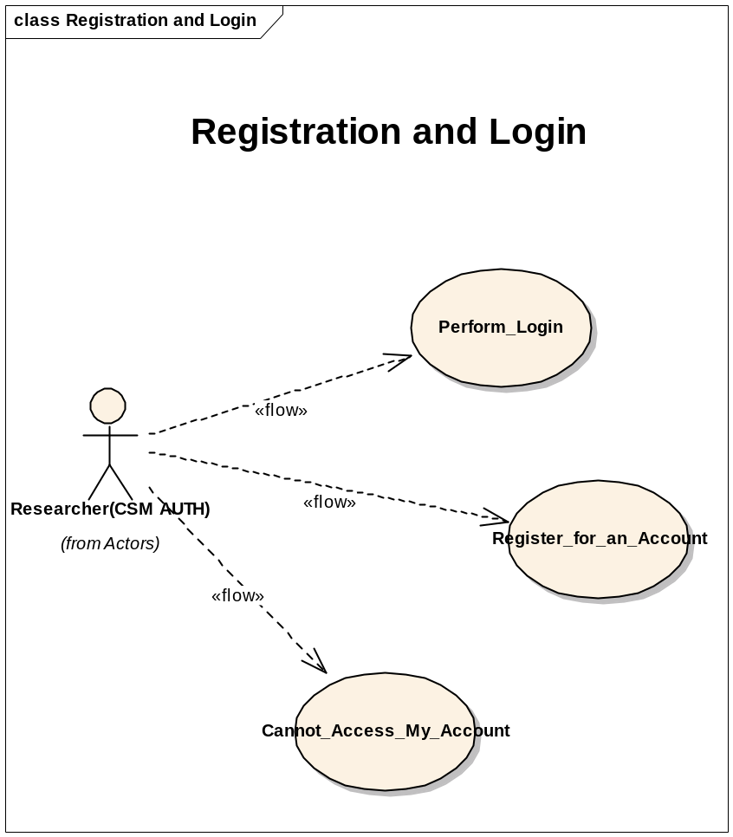

Registration and Login

Brief Description
The use case defines all the functions of the NCIA Home page. It provides the capability for the public to register for an account, login into the system and report problems with accessing the system such as “forgotten password”. In addition, it provides links to supporting tools and other websites plus general information and technical support.

Primary Actor
Researcher

Secondary Actors
- NCIA Software
- Applications Support

Preconditions

Precondition 1 – Researcher Has Access to NCIA Site
Researcher has access to the NCIA web site using a web browser that supports SSL and Javascript.

Basic Flow of Events
- NCIA shall provide the capability for a user to register for an NCIA account. See Alternative flow 1
- NCIA shall provide the capability for a user to access NCIA data via login account. See Alternative flow 2
- NCIA shall provide the capability for a user to report login account issues. See Alternative flow 3
- Use Case Ends

Post-conditions

Post-condition 1
NCIA system is in a normal state and ready for use.

Special Requirements
Not Applicable

Alternative

Alternative Flow 1: “Register for an account”
- NCIA shall provide the capability a public user to register as a new user in NCIA, from the NCIA welcome and login page.
- The user shall access the registration function by clicking the “Register Now” hypertext link.
- NCIA shall display the “Legal Rules of the Road” and “Private Act Notification Statement”
- The user shall review the “Legal Rules of the Road” and “Private Act Notification Statement” page, and then click the “Clicking Here” link to continue.
- Researcher is presented with the User registration form.
- Researcher submits the form.
- NCIA shall validate the registration form fields.
- NCIA shall add the user to the database
- NCIA shall grant the user read access to public data.
- User will be notified by email that the registration is complete and the account is active.
- User will receive emails that contain NCIA username and password separately.
- NCIA logs the user into NCIA.

Alternative Flow 2: “Perform Login”
- Researcher enters Login ID and Password and presses the Login button
- NCIA Software authenticates the user by validating login information against the database.
- If authentication is unsuccessful, the user is returned to the login page.
- If authentication is successful, the NCIA will:
  - Add a record to the LOGIN_HISTORY table.
  - Establishes the security rights of a user.
  - Populate all of the search fields on the Simple and Advanced Search pages as well as some other cached data.
7.2.5.3 Alternative Flow 3: “Cannot Access his/her account”
  - NCIA shall provide a link to a “help” for “user account” function.
  - Once clicked, NCIA shall display the “NCIA Account Help” popup screen.
    - A link to reset or retrieve a password from the NCI password station
    - Provide contact information including telephone numbers and email address
    - Provide instructions for submitting support requests

Exceptions
7.1.9.1 User Registration
a. NCIA performs a validation of the data entered by the user on the Register User page. Validations are implemented on the fields that require validation. The following validations occur:

- Fields with an asterisk have been populated
- Email and login ID are not already in use
- Phone number follows a valid format
- Email address follows a valid format
- The password and “retype password” fields match
- When errors are found, the user is returned to the Registration page with errors displayed.
7.1.9.2 Login Failure
a. In Case of Login Failure: Note:
NCIA shall display the message “Invalid Username/password. Please try again.” on the login page for incorrect user name and/or password.
NCIA display a popup window informing the user of a failure to login and its possible reasons.

Post Conditions
7.1.10.1User acquires an NCIA account
7.1.10.2 User logs into NCIA
7.1.10.3 User report login issues

Data

User Registration
- Legal rules of the road text
LEGAL FRAMEWORK AND ETHICAL USE OF THIS RESOURCE
The National Cancer Institute (NCI) offers this image repository to encourage cross-disciplinary science. Some of this data may already be published or in public domain. In addition, confidential information may be posted which has not yet been published or is subject of patent applications yet to be filed. Data may also be subject to copyright and commercial use may be protected under United States and foreign copyright laws. Other parties may retain rights to publish or reproduce these documents. In addition, some data may be the subject of patent applications or issued patents, and you may need to seek a license for its commercial use. Contact us if in doubt. If you are a contributor submitting data to this image repository, you are certifying that you are the original source of this data and are authorized to release the data that is permitted by your local IRB, when relevant. You also certify that you will consult with your institution's technology development office before posting or disclosing confidential information which may be patentable. You may browse, download, and use the data for non-commercial, scientific and educational purposes. However, you may encounter documents or portions of documents contributed by private institutions or organizations. NCI does not warrant or assume any legal liability or responsibility for accuracy, completeness or usefulness of information in this archive. Every effort will have been made to remove private health information (PHI) from images both by the submitter and again by tested automatic de-identification processes by the NCI as required by HIPAA for data use agreements [45CFR164.514(e)(4)], i.e., appropriate safeguards to ensure that protected health information (PHI) is not used or disclosed inappropriately. Nonetheless ethical principles command all users to make no attempt to identify individuals from whatever data elements and metadata remain. By continuing with this registration process, you understand that all necessary information describing the use of the system is detailed in the online help PDF documentation accessible from the left-menu bar from within the application.
USER REGISTRATION PRIVACY ACT NOTIFICATION STATEMENT
The National Cancer Imaging Archive (NCIA) web portal asks users to register. The use of this information is to allow the NCI to continuously improve the image repository as a public service. Collection of this information is authorized under Title IV of the PHS Act, Section 410[285]. This information may be disclosed to researchers for research purposes, contractors responsible for the maintenance of the repository and to other registered repository users for non-commercial, scientific and educational purposes. Submission of this information is voluntary. However, when registering please complete all fields. The NCIA web portal also records IP addresses and aggregated user query information. However, the IP address is not associated with any user registration information. The user registration data, IP addresses and aggregated user query information are used for NCI internal reporting purposes only to allow for improvement of the NCIA web portal based on users needs. For additional information, please refer to the Legal Rules noted above, and the link to our Privacy Policy. We do not use "cookies" on our web site. We do not give, share, sell or transfer any personal information to a third party. When inquiries are e-mailed to us, we store the question and the e-mail address information so that we can respond electronically. Unless otherwise required by statute, we do not identify publicly who sends questions or comments to our web site. We will not obtain information that will allow us to personally identify you when you visit our site, unless you chose to provide such information to us. To assure the integrity of information on this server, we reserve the right to monitor system access if malicious actions are taken to disable our on-line services or intentionally gain unauthorized access to NCI systems.

- Registration form data fields

User Registration
Data Item | Mandatory
Title | n
First Name | y
Last Name | y
Email | y
Organization Name | y
Phone | y
Fax | n

Login History

Login History
Date
Time
Login source
IP address

NCIA Account Help message

NCIA Account Help
NCIA has upgraded its authentication system to work with the NCI Standard login protocol. To log into NCIA, use your NCI network Account ID and Password.
Forgot your password? Click here to reset or retrieve your password from the NCI Password station.
If you have forgotten your user id or for additional support, please contact application support for assistance.
- Telephone: (301) 451 4384 or toll free (888) 478 4423
- Email: ncicb@pop.nci.nih.gov
Telephone support is available Monday to Friday, 8 am to 8 pm Eastern Time, excluding government holidays. You may leave a message, send an email, or submit a support request via the web at any time.
When submitting support requests via email, please include:
- NCIA on the subject line
- Your contact information
- A description of the problem and steps to recreate it
- The text of any error message you have received

NCI Password Station


Welcome to Password Station
SELF-SERVICE CROSS-PLATFORM PASSWORD RESET AND SYNCHRONIZATION

Primary Account
 | Domain:
 | User ID: | 

Privacy Policy & Terms of Use
Warning Notice!
This is a U.S. Government computer system, which may be accessed and used only for authorized Government business by authorized personnel. Unauthorized access or use of this computer system may subject violators to criminal, civil, and/or administrative action.
All information on this computer system may be intercepted, recorded, read, copied, and disclosed by and to authorized personnel for official purposes, including criminal investigations. Such information includes sensitive data encrypted to comply with confidentiality and privacy requirements. Access or use of this computer system by any person, whether authorized or unauthorized, constitutes consent to these terms. There is no right of privacy in this system.

Bottom of Form

Avatier Corporation is a registered trademark of Avatier Corporation. Copyright © 1995-2007 Avatier Corporation. All rights reserved. All other trademarks or registered trademarks are owned by their respective holders.

